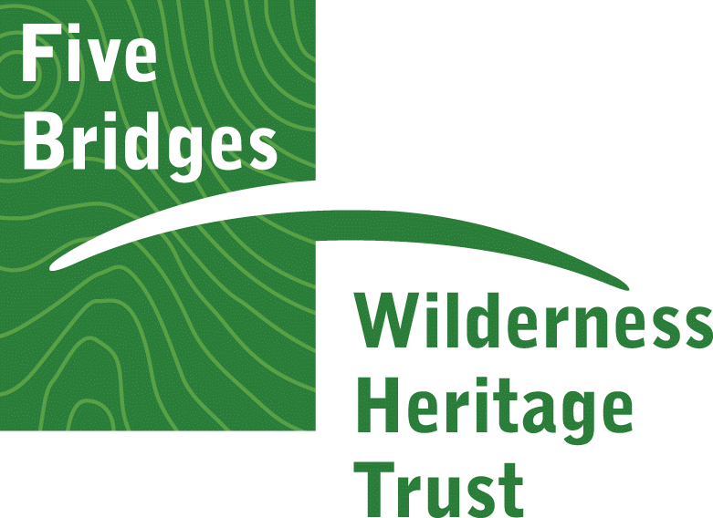
News Release
FOR IMMEDIATE RELEASE: Tuesday, December 1, 2020

Trust Launches Photo Contest
Encourages Community to Submit Best Shots From the
Five Bridge Lakes Wilderness Area – Chance to Win $200

Upper Tantallon, N.S. – Photographers young and old are eligible for prizes in a new Photo Contest launched this month by the Five Bridges Wilderness Heritage Trust. At a time when people are looking for healthy things to do, hiking or exploring in a wilderness area may be a fun way to spend some restorative time in Nova Scotia’s beautiful nature. The contest runs the month of December and entries may be submitted to the Trust’s email at fbwhtb@gmail.com. A key condition of entry is that the shot must have been taken within the Five Bridge Lakes Wilderness Area. Close to Halifax, it is a vast preserved space of undisturbed lakes, streams, rocky outcrops and forests that include the Bluff Trail Hiking Area, the Old St. Margaret’s Bay Road and spans 27,000 acres of the Chebucto Peninsula between HWY 103 and 333.
Photographers can enter their photo under one of two categories: Wilderness Fun or Wondrous Nature. A volunteer Jury will review all entries to select first, second and third prizes in Youth (18 and under) and Adult divisions. First Prizes include $200.
All winning shots will be exhibited as part of a show at the Tantallon Library and featured in the February edition of The Masthead News community newspaper. See the Trust’s website www.fivebridgestrust.ca for Contest Rules, wilderness area map and more details.
The FBWHT is a Canadian non-profit volunteer organization working to preserve, protect and promote use of the Five Bridge Lakes Wilderness Area, a popular destination for hikers, fishers, canoers, kayakers, ATVers and nature lovers alike. Trust activities are funded through annual Memberships ($10 for Individuals/ $15 for Families), donations and a Partnership with the Bay Treasure Chest.
-30-
Media Contact:
Joanne Ellis
fbwhtb@gmail.com
Tel: 902 826 9512

